**Problem 1: Count any character (ex-a) in a string**

**Solution:**

1. Need a for loop to read input password
2. Need a variable currentCharacter while reading string ( for every character in input string).
3. Check if the current character in loop is our required character. In this case ,a
4. Need a variable currentCount to store the count if meets the previous condition

**Sample input:**

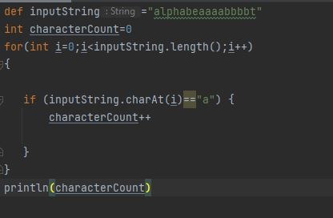

**Output:**

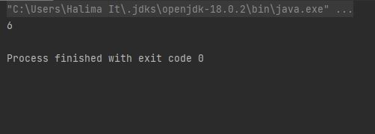

**Problem 2: Count all the characters in a string with ignoring space.**

**Solution:**

1. As the count is related to a specific character, map is the best choice here. The character will be the key and the count will be the value, which will be modified.
2. For only lowercase, we have to create a map with all the lowercase characters with default count 0
3. To count uppercase characters, digits, special characters, we need 3 more maps .
4. Now we need a method that will read our input string and count the characters.
5. For any method, we have to

* give an appropriate name that helps with readability
* decide the parameters
* decide what the method will return .

1. For this particular method, we need a for loop to read the input string. For every character, we need a variable currentCharacter . this will find this current character in map. If the character is not in any of the map, (that means spaces) the value will be null as we assigned zero to every character.
2. We need another variable to store the count, currentCount. This will be updated as the new value in map.
3. Lastly, the method will return the map with count of every character.

**Sample Input**

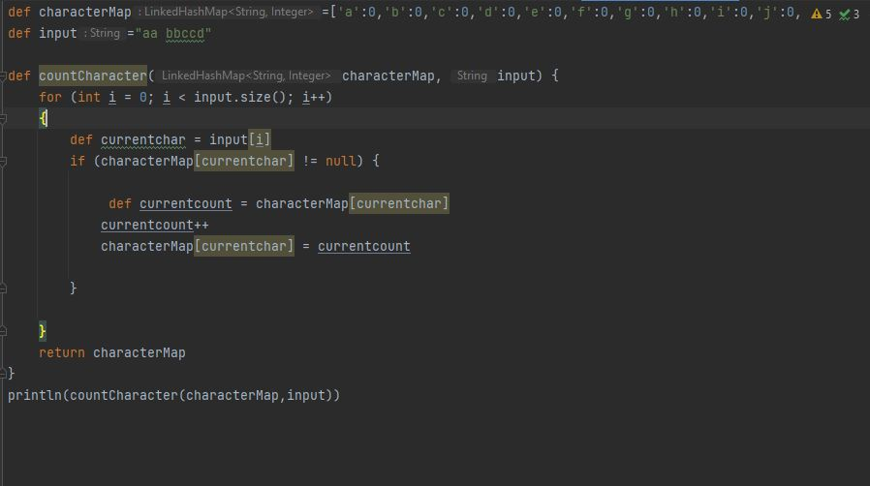

**Output**

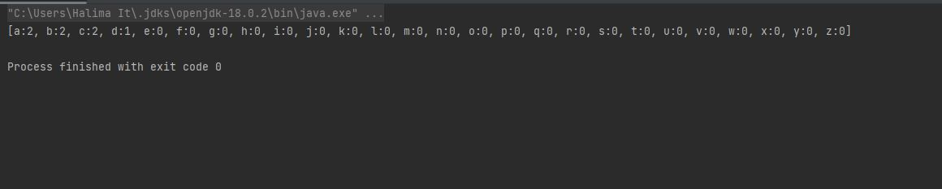

**Problem 3: Checking whether the Input Pasword satisfies all the condition of checking password strength**

**Solution:**

1.To solve the problem we need four list(Uppercase,Lowercase,Digit & Special Characters) and Input Password string.

2. Now we need a method that will read our input string & compare it with the Character list ,it will return a Boolean value whether the character is present in the character list.

3.In the method we have to take a Boolean variable ,a character count and a empty map.Now we have create a map for each character list.

4. We need a for loop to read the input string. For every character, we need a variable currentCount this will find this current character in map.If the currentCount is not null then it will update the value of boolen variable from false to true.

5. If the condition matches only once we don’t to continue the loop,we return from then and there(return from If )

**Sample Input:**

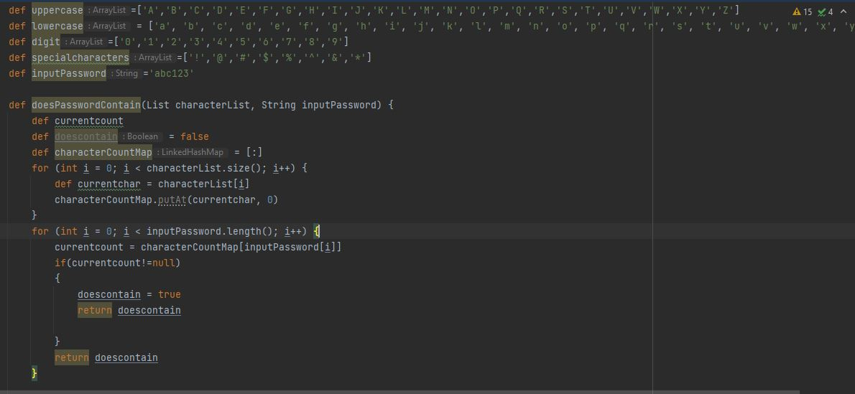

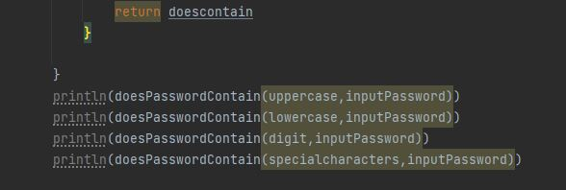

**Output:**

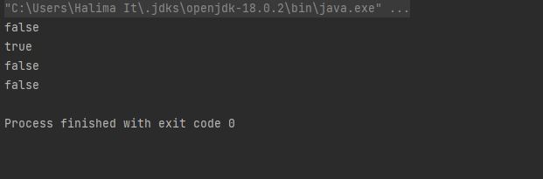

**Problem 4. Getting Password Strength By Score**

**Solution:**

1. To solve the problem we need four lists (Uppercase,Lowercase,Digit & Special Character) ,Input password string and five variables with corresponding score.

2. Now we need a method that will read our input string & compare it with the Character list,it will return a score value .

3. In the Method we declare variables current count,scoreifdoescontain(assign it value to zero)and a empty map. Now we have create a map for each character list.

4. We need a for loop to read the input string. For every character, we need a variable currentCount this will find this current character in map.

5. If the currentCount is not null then it will return the score value and if the currentCount is null the value of scoreifdoescontain is updated with the value of score.

6.Now we print all the score value for each list and then chack if the password length is less than 8,if so then make the value of length count is zero.

7.Lastly we take all the score value in different variables and the add them together to find the total password strength value in percentage .

**Sample Input :**

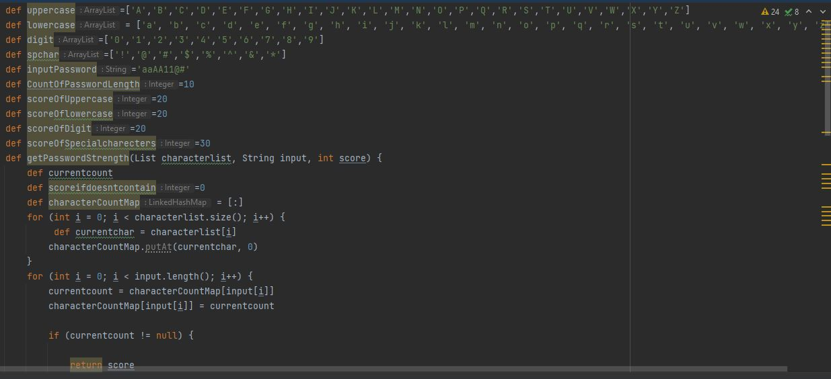

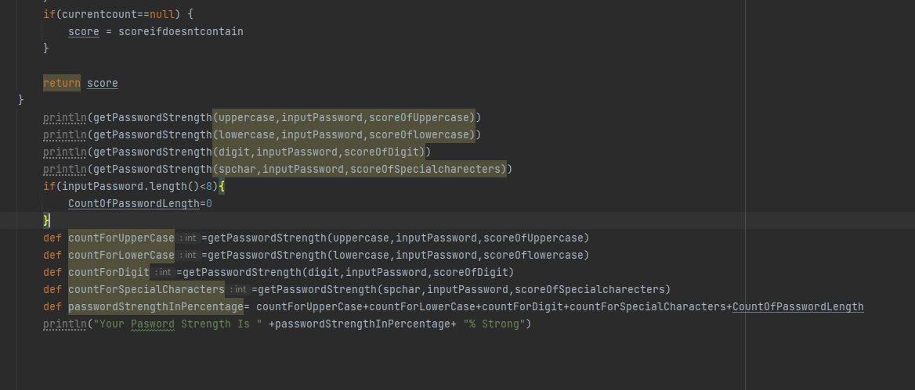

**Output:**

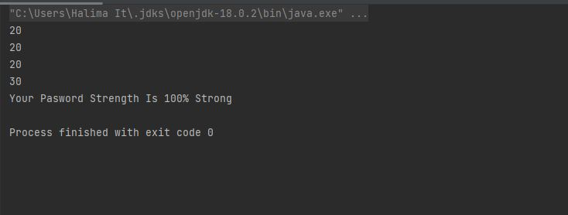

**Improvised Version (No Map & Current Count):**

